
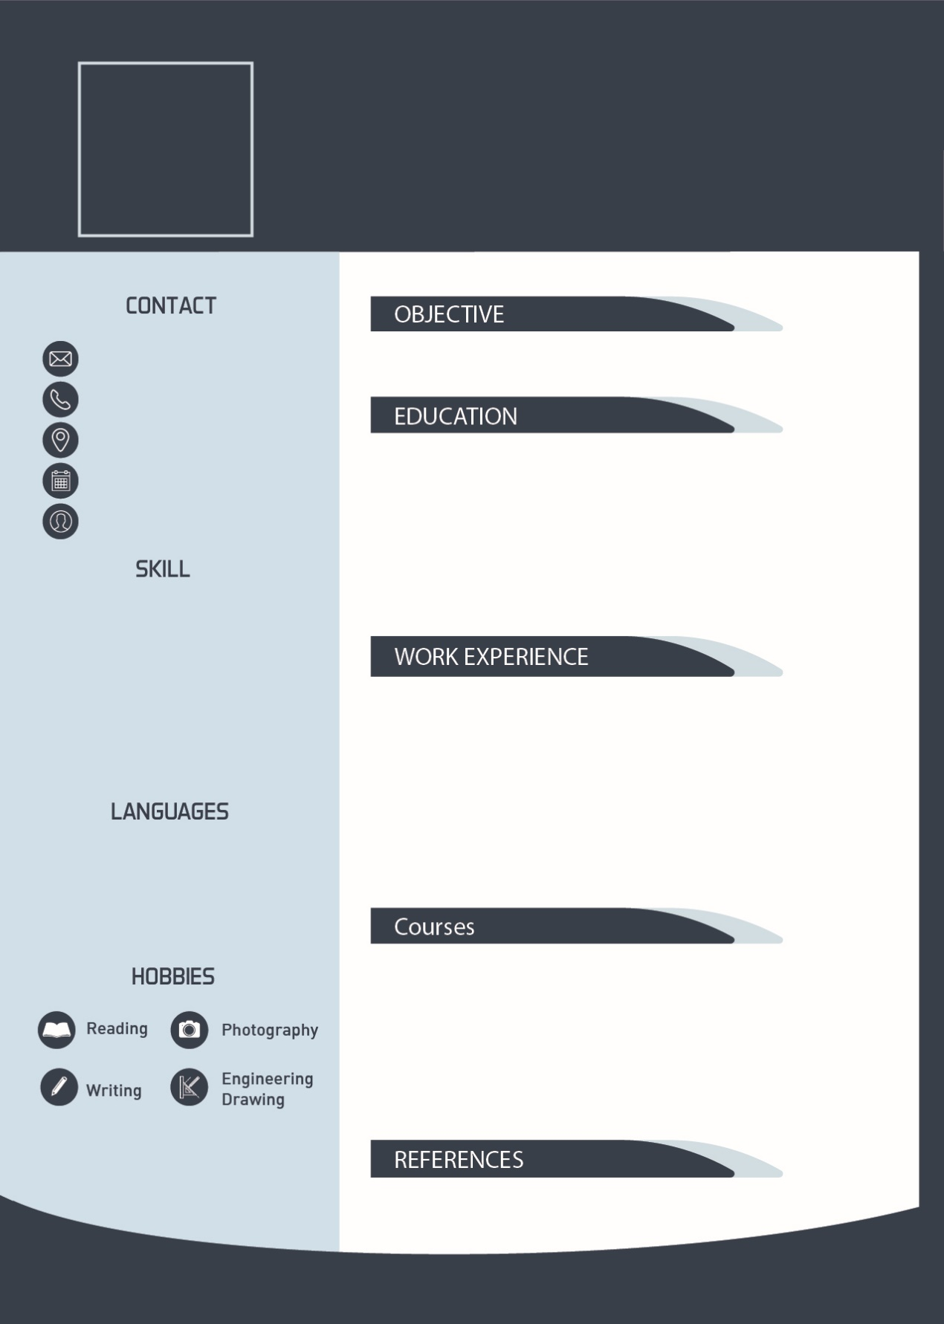
Yaser Mohammed’s CV
GRAPHICDESIGNER

My Objective is to find a suitable job that help me to improve and success in my career …..etc
[بريد أُزيل]
0097123456789
Dubai, UAE
Date of Birth
Single

- Diploma in G.Design – 3.5/4 – ABC University
- Bachelor in G. Design – 3.7/4 – ABC University
- Master in G. Design – 3.9/4 – XYZ University

- Training – ABC University – 6 Months
- My first job – ABC Company – 2017 to 2018
- My Second Job– XYZ Company – 2018 to current

- Arabic (Fluent)
- English (Very Good)

- 2017: Time Management Course – ABC Institute
- 2017: Team work Course – ABC Institute
- 2018: G. Design labs course – AKO Institute

- Computer Skills
- Soft Skills
- Office skills
- Adobe Creative
- Etc….

- Ahmed Ali, DXV Designers - 050123456789

